Bahria University

# Computer Science Department



**Submitted By:**

* MUHAMMAD FARAZ
* ENROL:02-134171-147
* BS(CS)_4B
* REGISTRATION NUMBER:48536

**Submitted to:**

* Miss Laraib Tahir

**Submission Date:**

[15/10/2018]

**DEPARTMENT OF COMPUTER SCIENCE**

**BAHRIA UNIVERSITY, KARACHI CAMPUS**

|  |
| --- |
| EXERCISES |

**TASK # 01**

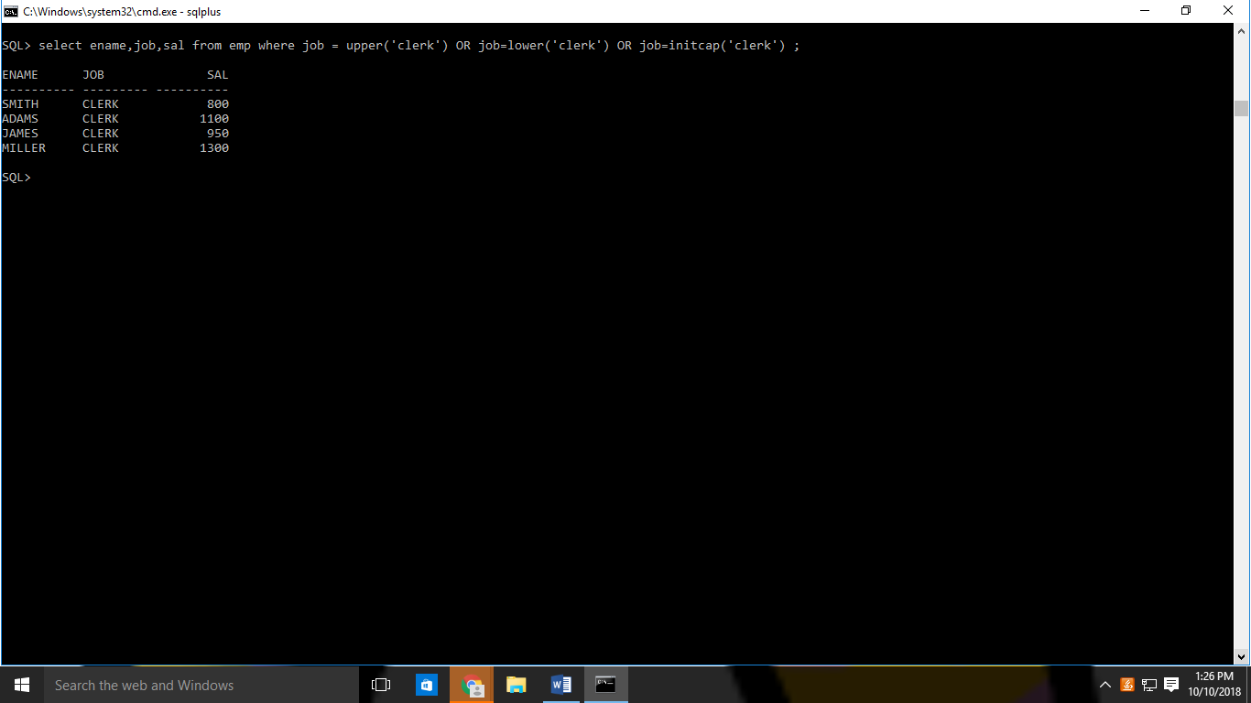

**TASK # 02**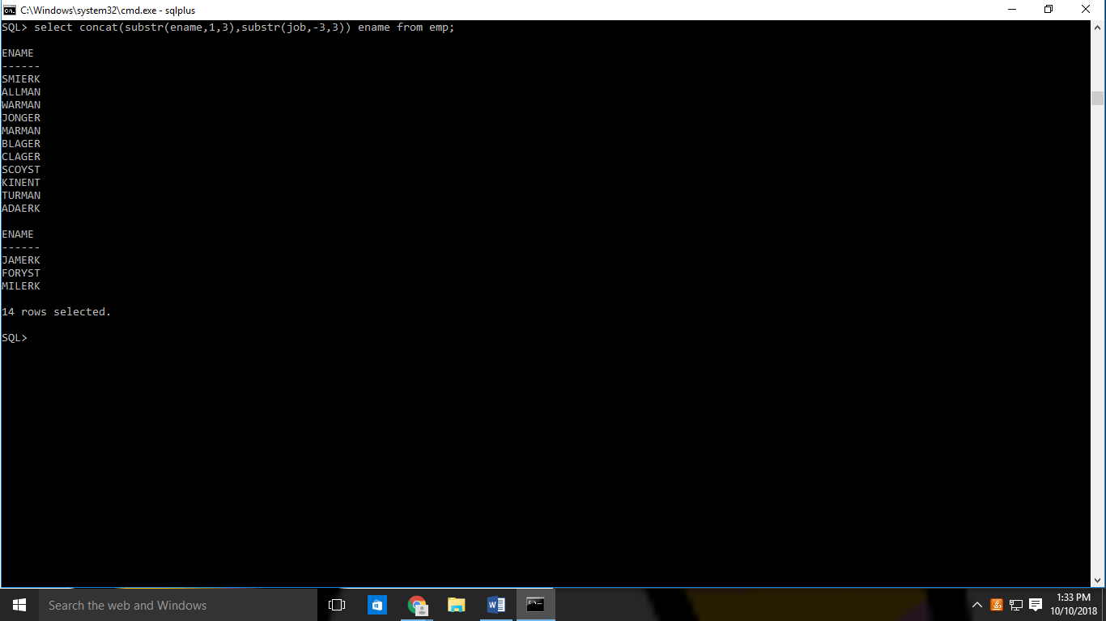

**TASK #03**

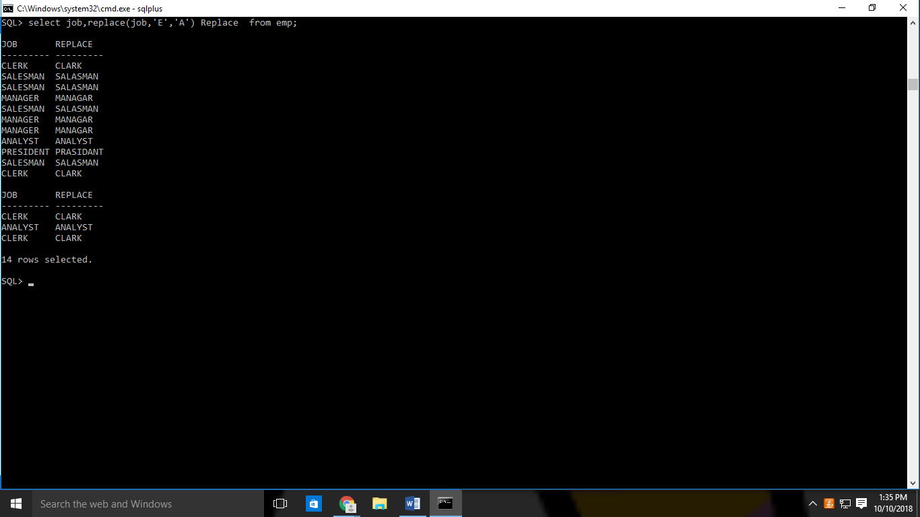

**TASK#04**

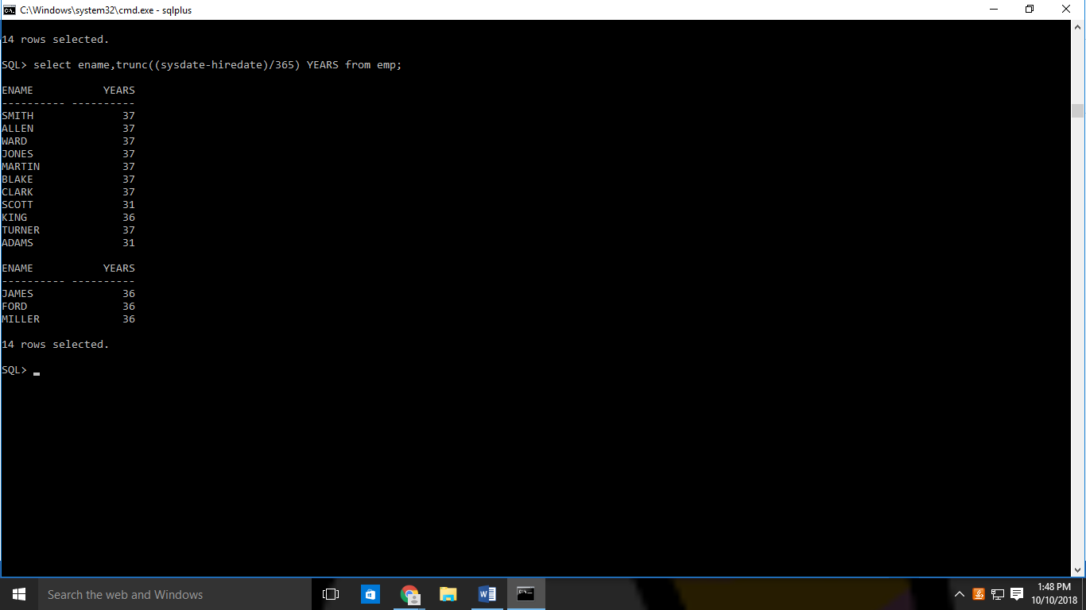

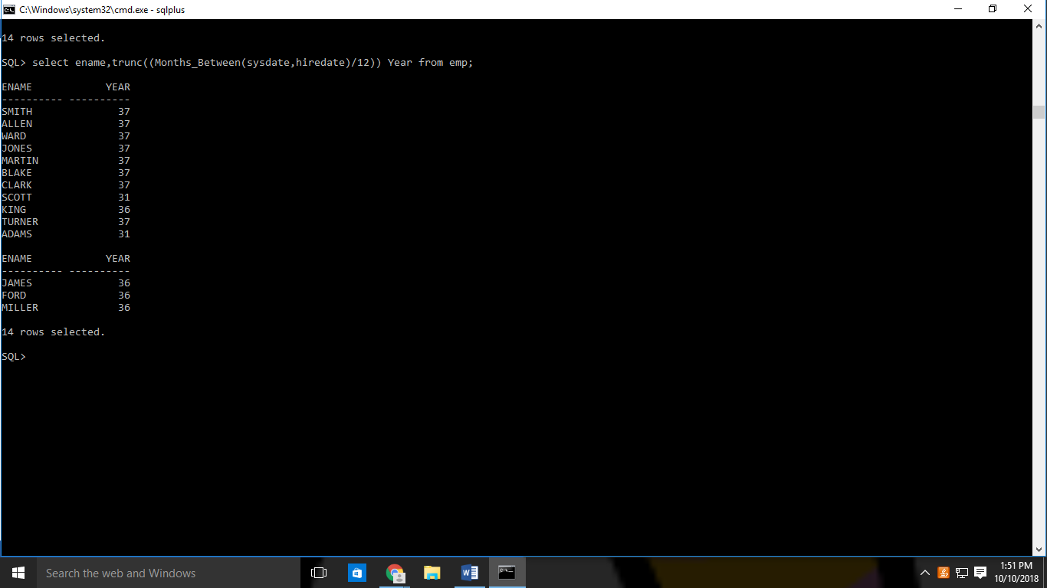

**TASK #05**

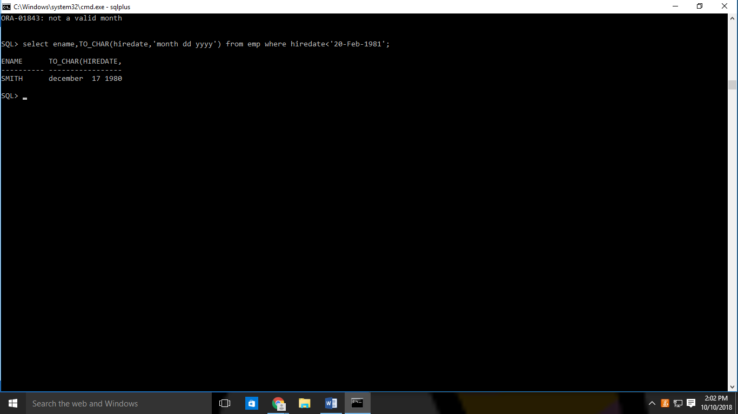

**TASK #06**

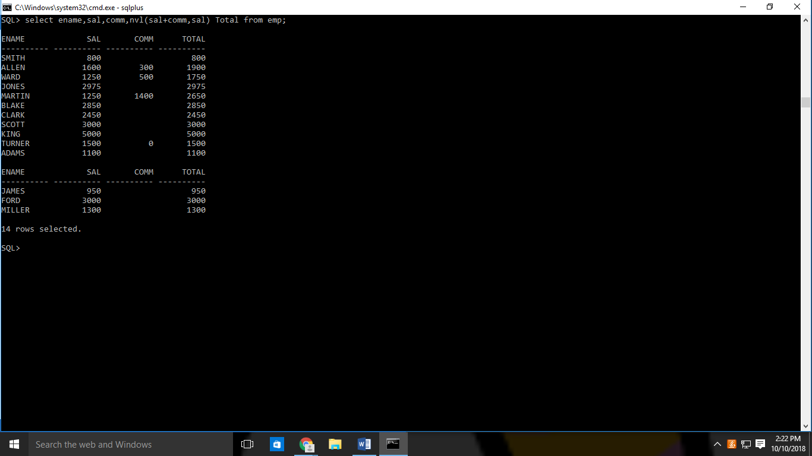

**TASK #07**

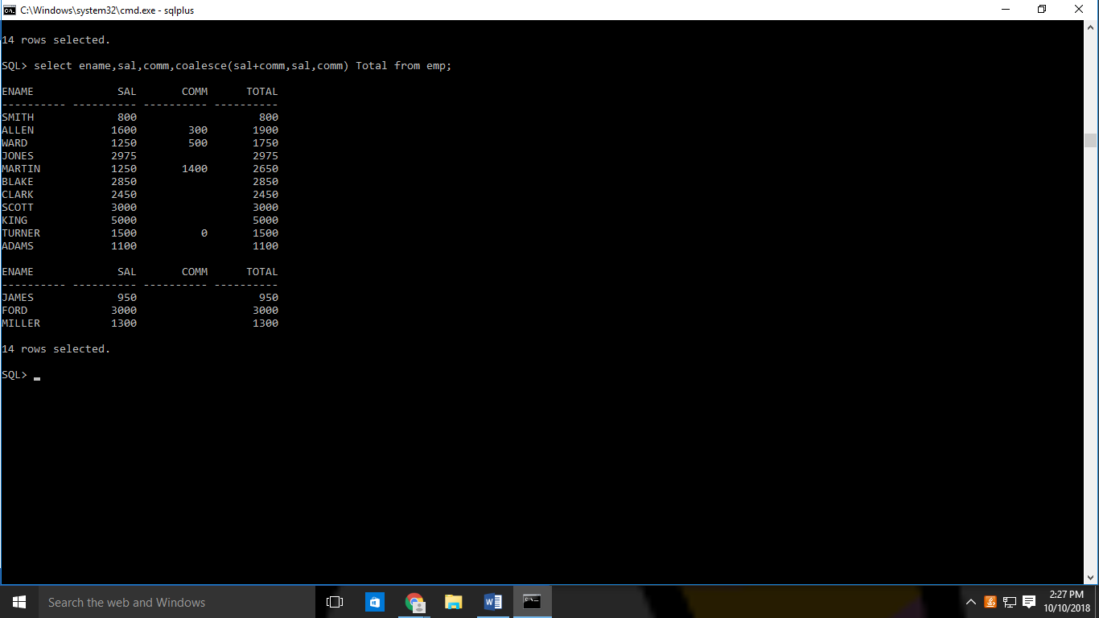

**TASK#08**

